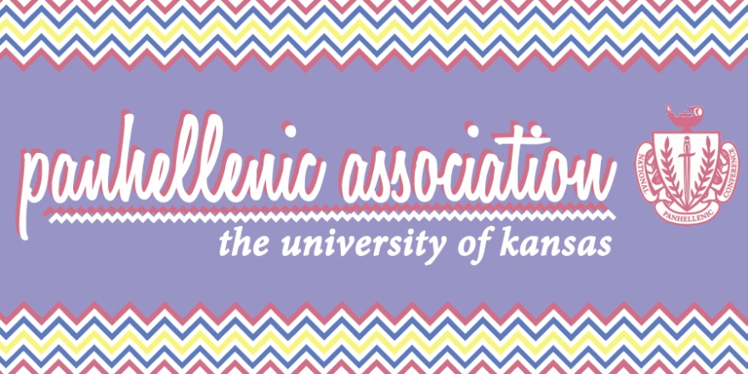
Panhellenic Association
Agenda
Delegates
Chi Omega
5/3/16
- Call meeting to order
- Roll Call
- Panhellenic Creed
- Guest Speakers
- All Greek Update
- Executive officer report

Johanna Hecht, President: phapresident@ku.edu
- Please make sure we have a calendar of your chapter's events for the Fall anything that you have tentatively planned
- Still check your email/GroupMe over the summer...we still be in contact! At least once a week please!!
- Remind your members to still be mindful of what they post on social media during the summer we always need to uphold our values and standards even when we are not at school!
- Sending out the Fall council schedule in the minutes tonight: Please let me know if a date conflicts with an event at your chapter new member education, etc. anything that is going on!

Katie Fragen, Vice President: phaadminaffairs@ku.edu
- Expenditures:
- KU Info Tech dues: $84
- Study-a-thon reimbursement: $211.04

Jamie Adamson, Public Relations: phapr@ku.edu
- Guidebook is being finalized this week. All chapter advisors and recruitment chairs should've received the link to review/confirm your chapter's info, try to do that by Wednesday (tomorrow) any corrections by TOMORROW
- PR delegates look out for email concerning summer goals
- Finals Study-a-Thon next week. Look out for details on that!

Alle Flamme, Risk Reduction: phariskmgmt@ku.edu
- Have a fun and safe summer everyone! :)

Caitlin Chen, Formal Recruitment: pharecruitment@ku.edu
- Finalizing recruitment plans she will be in the panhellenic office all summer
- If you need me I'll be here all summer!
- Disaffiliation day for anyone recruitment related is May 14th, June 10th chapter social media of recruitment people needs to be cleaned!

Abbie Parker, Informal Recruitment: phaassistrecruit@ku.edu
- THANK YOU SO MUCH FOR THIS WEEKEND.
- MRABAs if you have any last minute ones please let Abbie know!

Liz Gray, Interfraternal Relations and Membership Development: pharelations@ku.edu
- Homecoming Meeting Wednesday at 7:30pm in Kansas Room Homecoming chairs need to be there
- New Member Education program development in the works for the fall it’s going to be one day this year in 3 different session, new members will need to attend a session.
- Phi Iota Alpha, an MGC fraternity is hosting their probate, or new member presentation, is on Wescoe Beach this Wednesday at 7:31pm. Dress is casual. Please promote for your members! They’re super fun, really try to promote it!
Anna Herrick, Scholarship: phascholarship@ku.edu
- Next week is the Study A Thon! Be on the lookout for binders in the libraries and encourage your members to participate. Winning chapter gets free pizza on PHA!
- Can also do study hours at the house like last semester!

Rachel Bender, Community Service: phacommservice@ku.edu
- Circle of sisterhood exec board applications are on rock chalk central under forms! They close Friday the 13th and midnight! Under forms in the Panhellenic Organization
- Service hours are due on Stop Day. 10 per member as always!

Taylor Austin, Judicial Affairs: phajudicial@ku.edu
- No report
- Delegate Reports
  - Alpha Chi Omega: Amanda Rebori, axophi.panhellenicdelegate@gmail.com Had a sisterhood day at the K, formal was last weekend at the Oread, on Sunday had an ice cream social with Chi Omega.
  - Alpha Delta Pi: Megan Mandl, taupanhellenic@gmail.com Friday had lemonadpi, last weekend had and alumni event, doing recruitment workshops!
  - Alpha Gamma Delta: Caleigh Stockebrand, agdproperty.eb@gmail.com formal this last weekend at the Eldridge, senior sendoffs!
  - Chi Omega: Margaret Reed, margejreed@gmail.com brunch for house mom, ice cream social with Alpha Chi Omega!
  - Delta Delta Delta: Kelly Werther, kellywerther@ku.edu pansy breakfast for seniors, senior send off party on Thursday! Percentage night at noodles tonight with Delta Chi!
  - Delta Gamma: Haley Haines, bkdgpanhellenic@gmail.com had mom’s weekend and senior send off!
  - Gamma Phi Beta: Lacey Bolen, laceyjean11@gmail.com house community service event on Friday and senior week is this week!
  - Kappa Alpha Theta: Peri Ogg, periogg@sbcglobal.com Had casa cookout last Wednesday, spa night sisterhood event, senior dinner!
  - Kappa Delta: Kenley Childs, kenley.childs@gmail.com formal last weekend, confidence event on campus!
  - Kappa Kappa Gamma: Emily Minick, ekminick@gmail.com Last chapter last night and seniors alumned.
  - Pi Beta Phi: Mackenzie Anderson, mackenzie_anderson22@yahoo.com senior farewells last Sunday!
  - Sigma Kappa: Morgan Harris, panhellenicdelegate.skku@gmail.com had formal this last weekend, order of the triangle ceremony for the seniors, sisterhood movie night!

- Advisor Report, Royonah Marble: royonah-marble@ku.edu

- Old Business: SDT Suspension language: Alpha Delta Pi motions to discuss, Chi Omega seconds (no discussion). Chi Omega motions to vote, Kappa Delta seconds. Passes 12-0
- New Business
- Adjournment

~~~***HAVE A GREAT SUMMER ***~~~

